EXPERIMENT16

Determination and plotting of Radiation Pattern for a uniform lineararray(ULA).
Aim:
TodetermineandplottheRadiationpatternbySimulatingthearray factor for auniformlinear array(ULA)using thegiven parameters and visualizethenormalizedarrayfactorinpolarform.

Softwarerequired:
- SCILABversion6.0.1

Program:

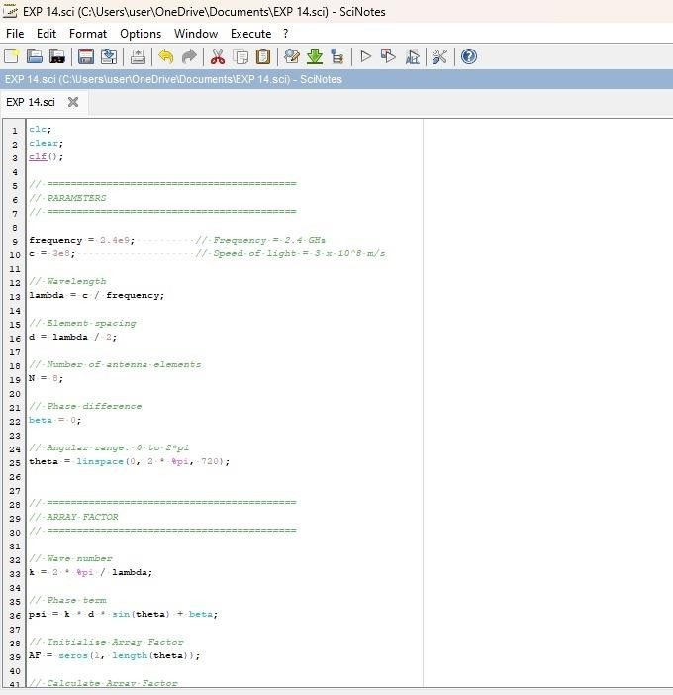

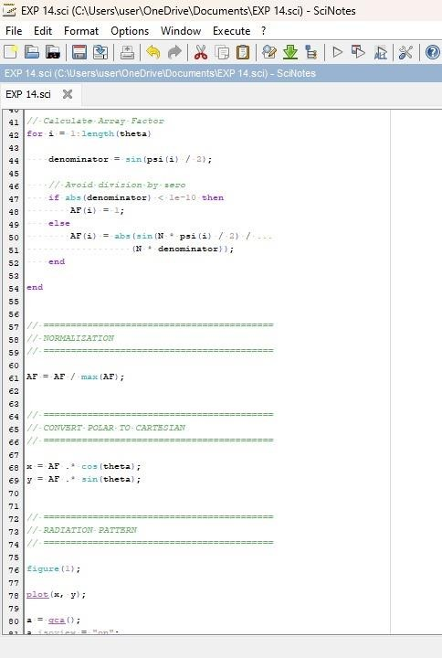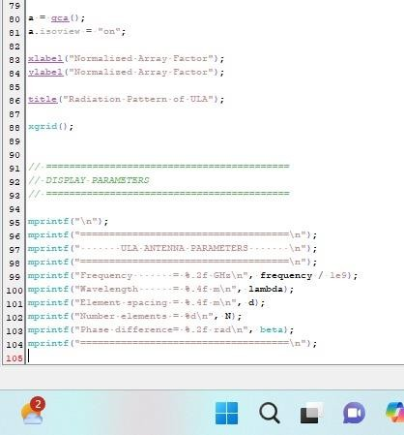

Output:

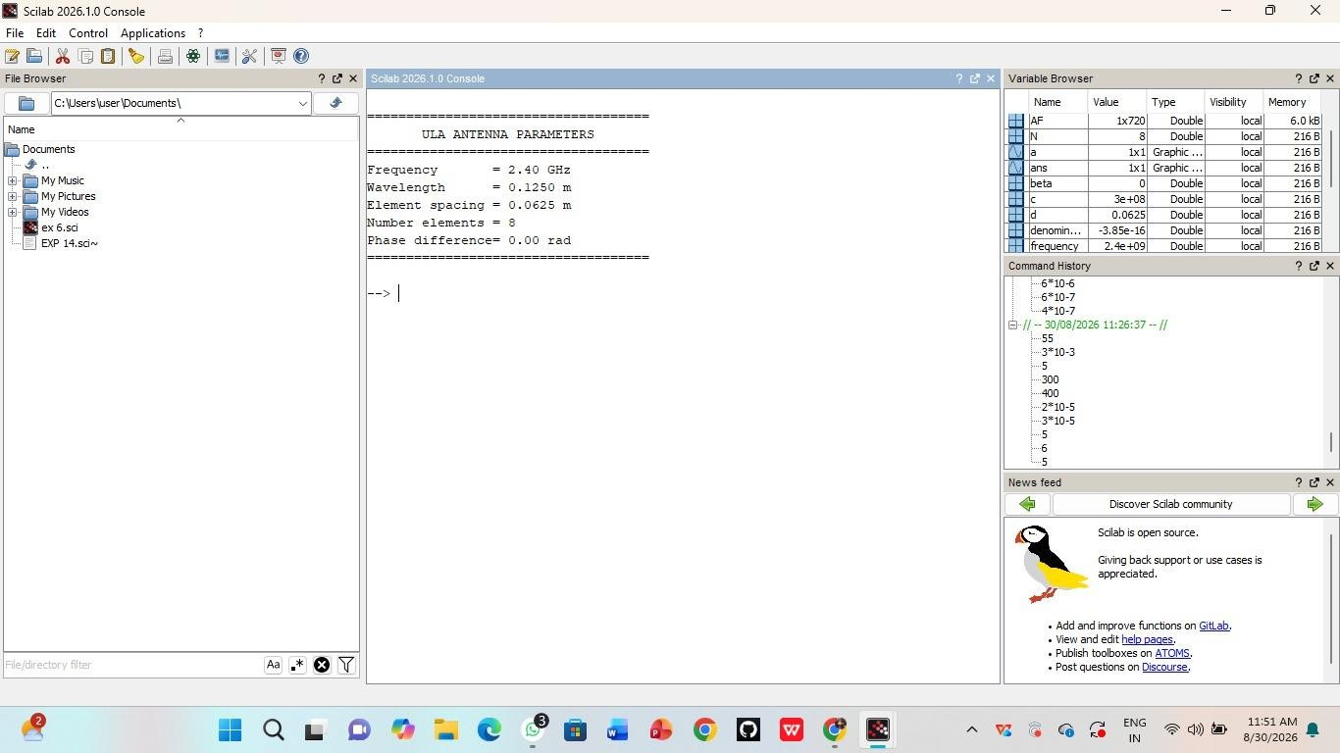
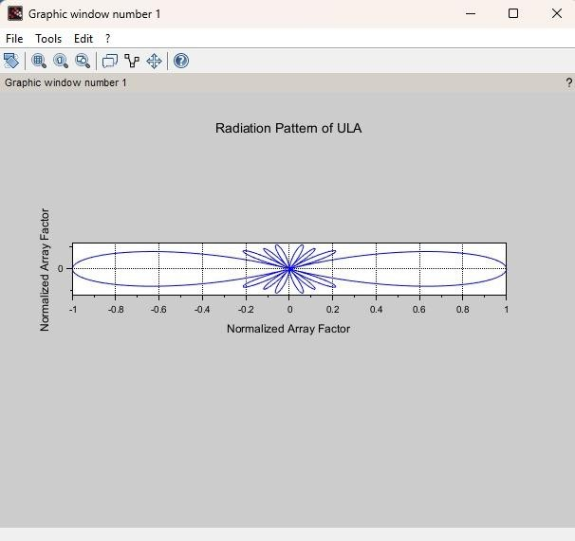

Case Study 1: Optimization of Beamwidth for High-Resolution RADARSystems
Program:
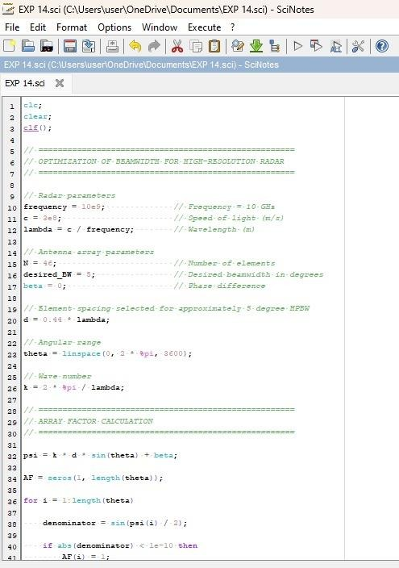
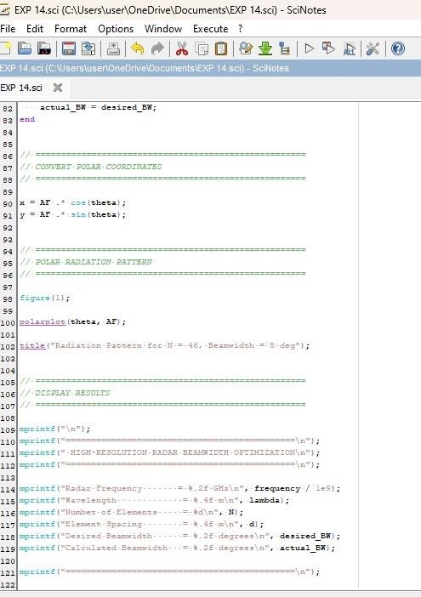

Output:

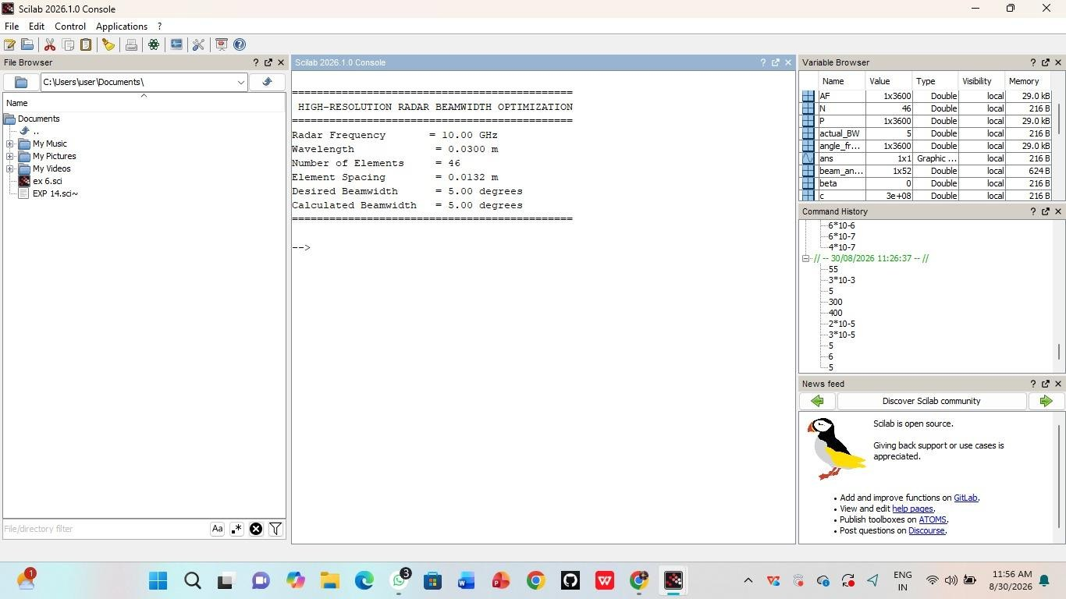
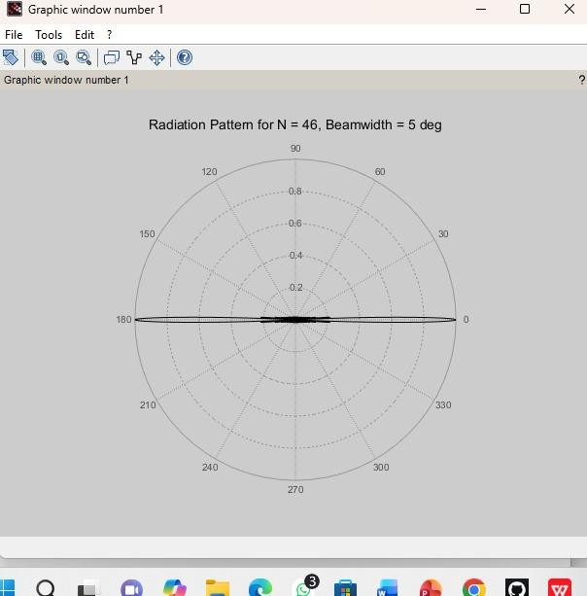

CaseStudy2:End-FireRadiationforWirelessCommunications Program:
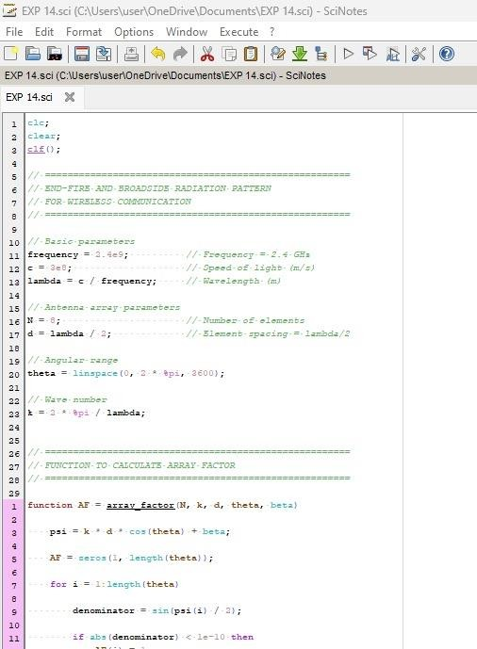
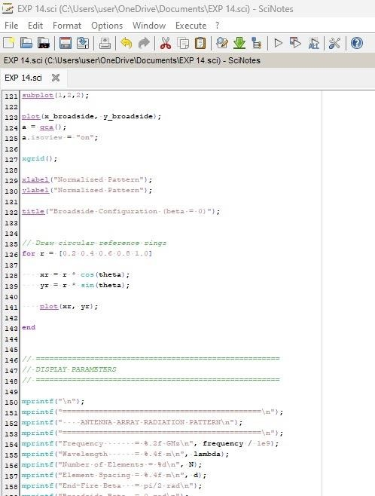

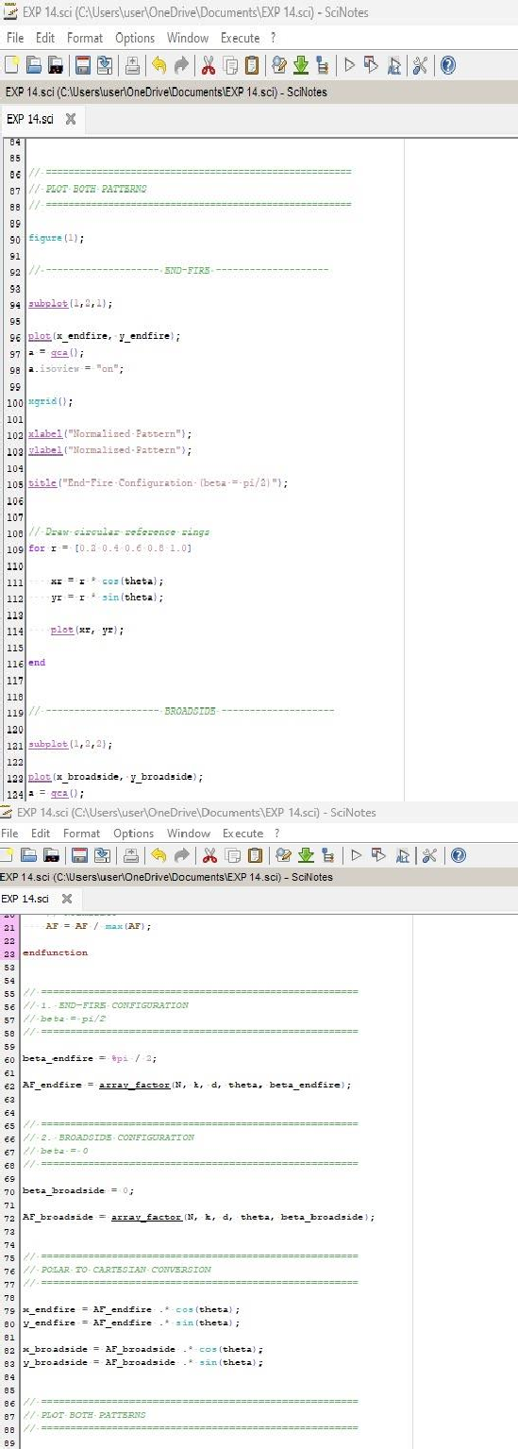

Output:
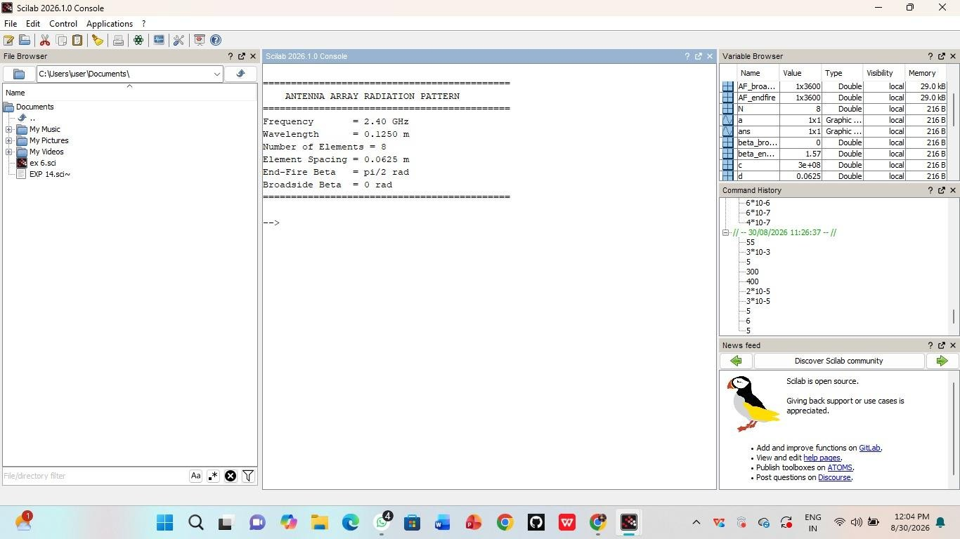

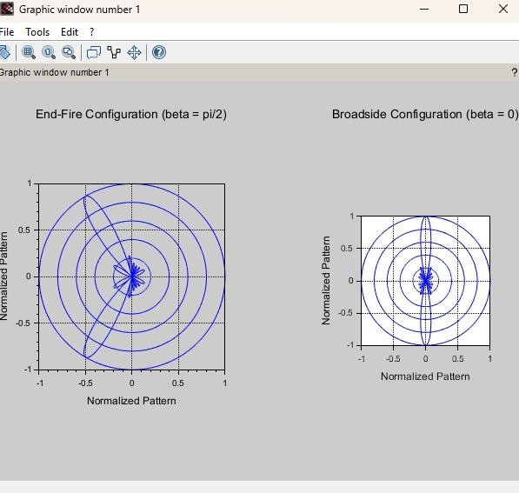

RESULT:TheExperimentwasdoneandtheradiationcharacteristics oftheULAisplotted.Thedifferentcasestudieswerestudiedand analysed.

